**DAILY ONLINE ACTIVITIES SUMMARY**

|  |  |  |  |  |  |
| --- | --- | --- | --- | --- | --- |
| **Date:** | | **13/06/2020** | **Name:** | **JASLINE SHARON TAURO** | |
| **Sem & Sec** | | **4th sem, A Section** | **USN:** | **4AL18CS029** | |
| **Online Test Summary** | | | | | |
| **Subject** | **DATA COMMUNICATION** | | | | |
| **Max. Marks** | **30** | | **Score** | **13** | |
| **Certification Course Summary** | | | | | |
| **Course** | | Application Developer | | | |
| **Certificate Provider** | | **AWS Educate** | **Duration** | | **3 hrs.** |
| **Coding Challenges** | | | | | |
| **Problem Statement:**   1. Write a C program to remove specific characters in the String. | | | | | |
| **Status: EXECUTED** | | | | | |
| **Uploaded the report in GitHub** | | | **YES** | | |
| **If yes Repository name** | | | <https://github.com/jaslinesharontauro/C_Prgms> | | |
| **Uploaded the report in slack** | | | **YES** | | |

Online Test Details: (Attach the snapshot and briefly write the report for the same)

Certification Course Details: (Attach the snapshot and briefly write the report for the same)

Coding Challenges Details: (Attach the snapshot and briefly write the report for the same)

CERTIFICATION COURSE DETAILS:

Today I have continued the course “Application Developer” by AWS Educate. In this course today I learnt about Software as DevOps and infrastructure as code. I have successfully completed the Second module of this course and first assessment of this course.

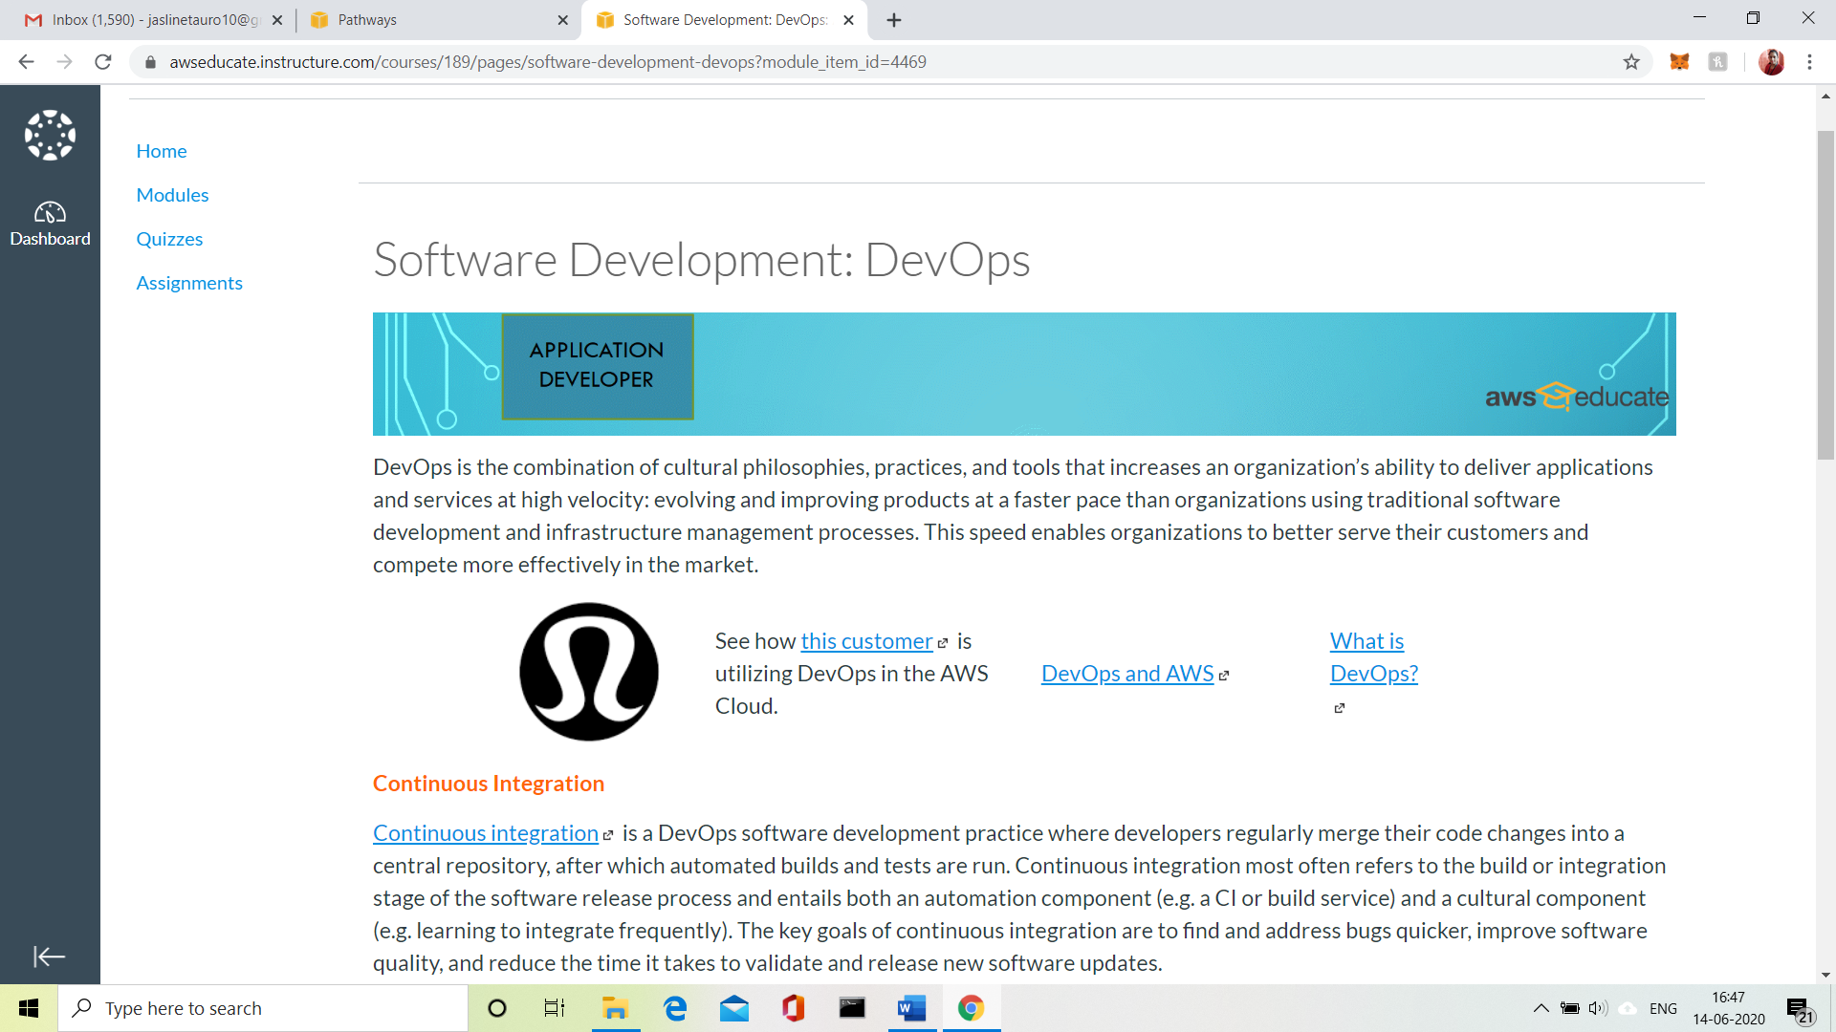

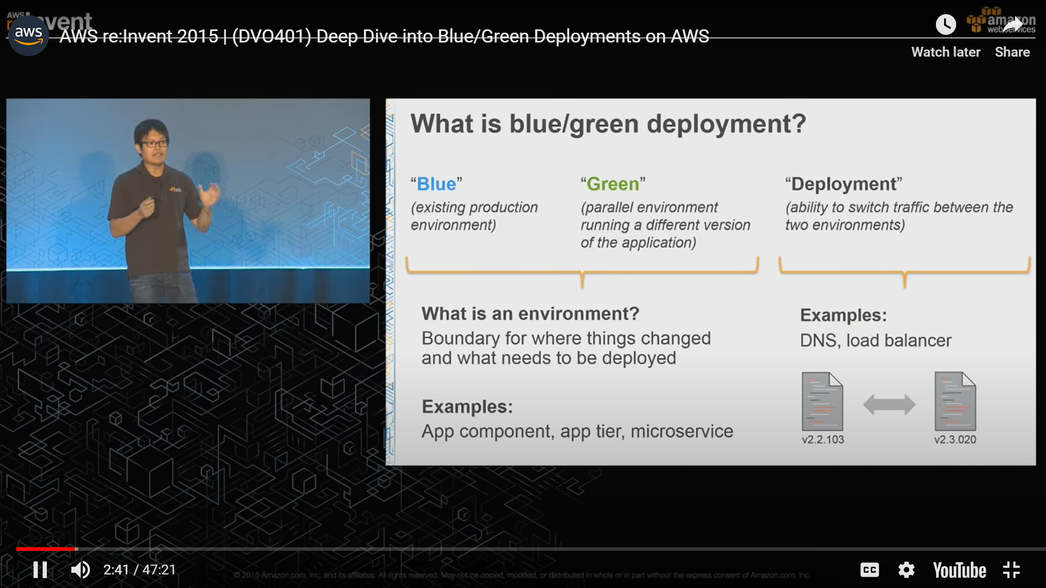

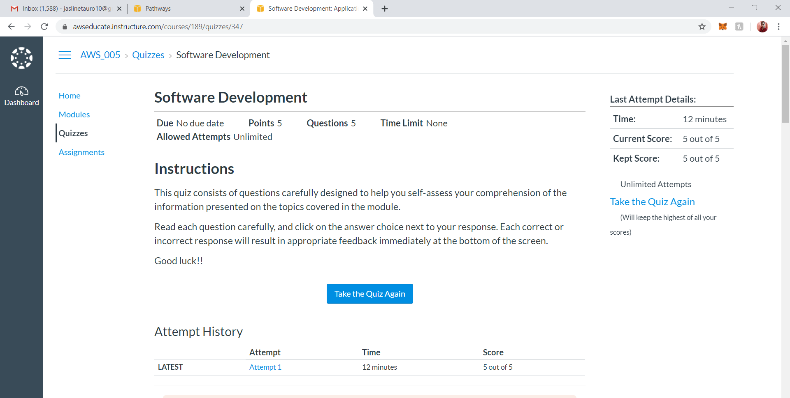

3.CODING CHALLENGES:

Problem Statement 1:

 Write a C program to remove specific characters in the String.

Example  
If the original string is "Welcome to AIET" and the user inputs string to remove "co" then the it should print "Welme to AIET" as output.

**Input**  
First line read a string  
Second line read key character to be removed.

**Output**  
String which doesn't contain key character

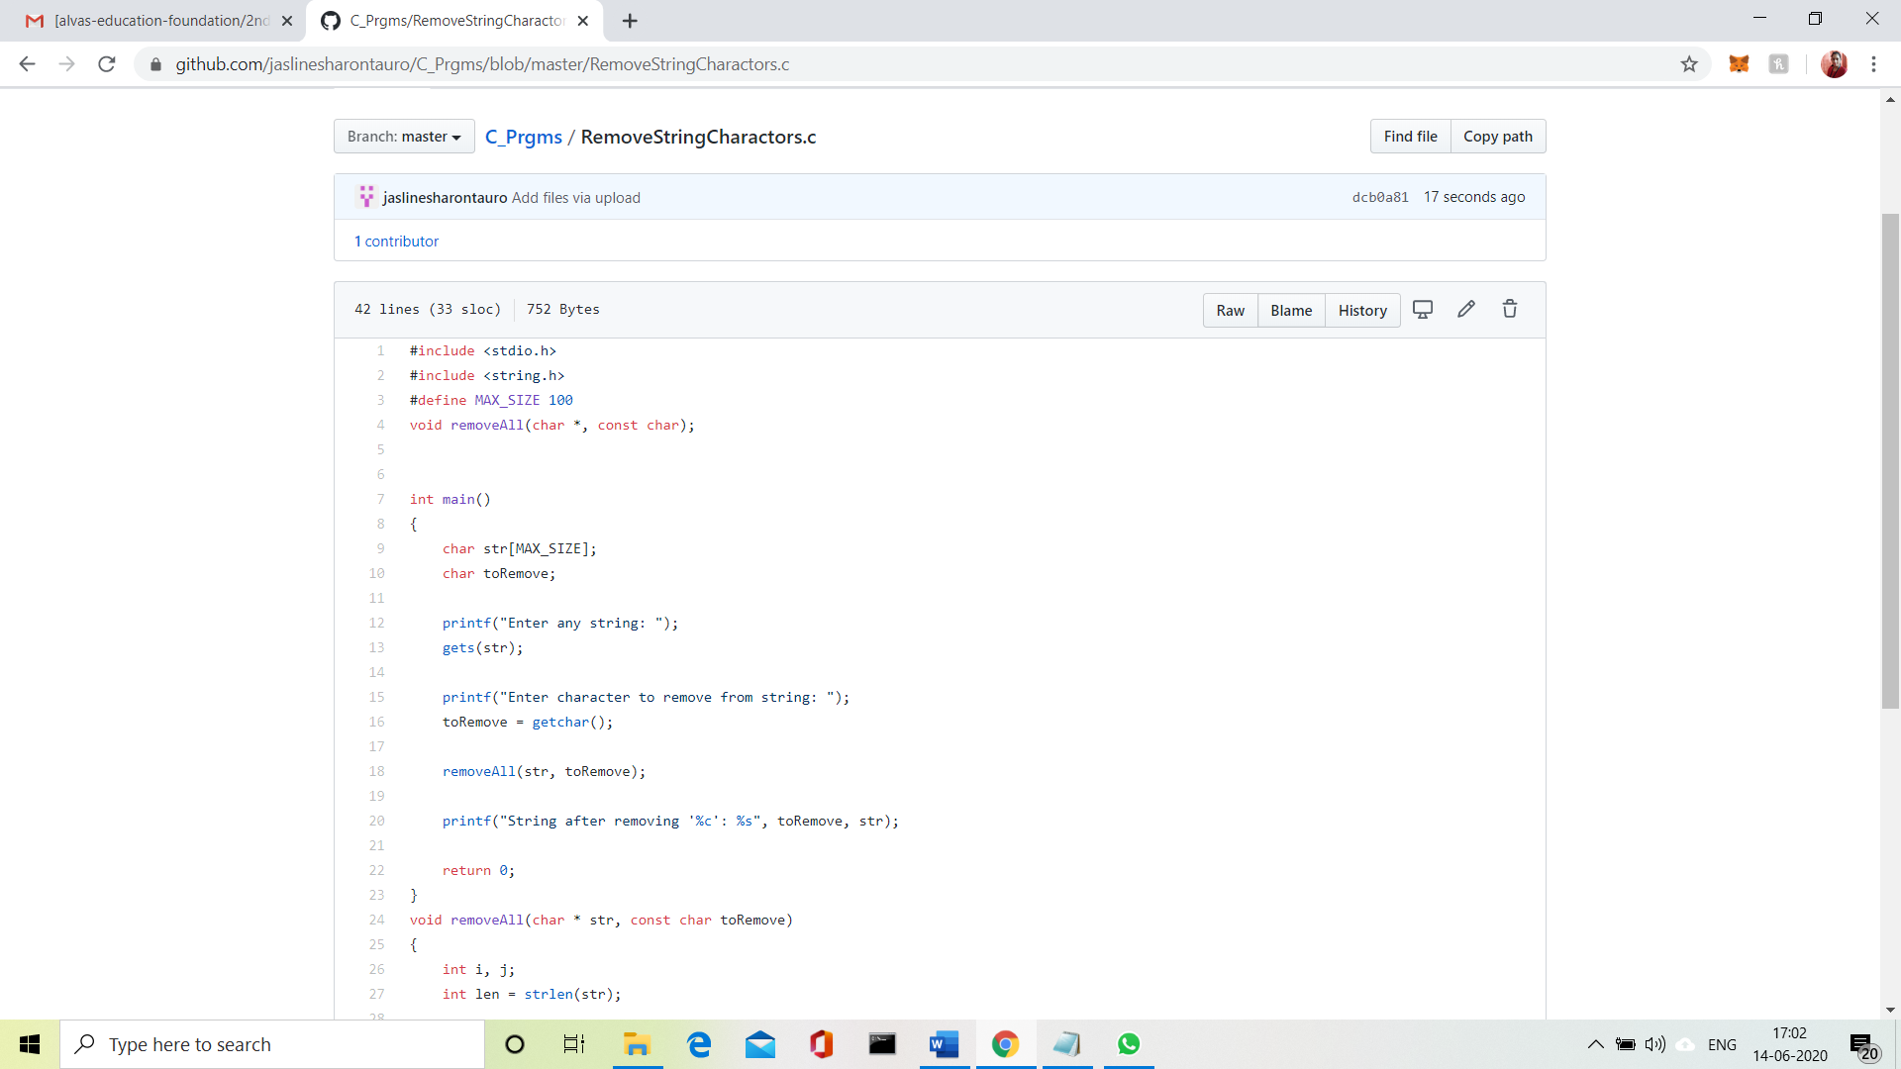

Solution uploaded in GitHub.